**HIT140: Foundation of Data Science**

**Assignment: 3**

**Submitted by: Group 51**

|  |  |
| --- | --- |
| **Member name** | **Student ID** |
| Harsh Rastogi | S386401 |
| Hena Akter | S383478 |
| Princyben Chetankumar Patel | S388343 |
| Renish Rajeshkumar Vekariya | S374427 |

Charles Darwin University, Danala, Darwin, NT

Contents

1. INTRODUCTION 3

2. DATA AND METHODOLOGY 5

2.1 Datasets 5

2.2 Data Cleaning 5

2.3 Analysis Methods 5

3. Analysis of Predator's Perception 3 6

3.1 Vigilance Behaviour 6

3.2 Risk Behaviour 7

3.3 Success Rates 7

3.4 Timing Patterns 8

3.5 Summary 8

4. INVESTIGATION B: SEASONAL ANALYSIS 8

4.1 Seasonal Distribution 8

4.2 Vigilance Across Seasons 9

4.3 Rat Activity 9

4.4 Changes in Risk Taking 10

4.5 Bat Activity Levels 11

4.6 Success Rates 11

4.7 Putting It Together 12

4.8 What This Means 13

5. DISCUSSION AND LIMITATIONS 14

5.1 Main Findings 14

5.2 Limitations We Should Mention 14

5.3 Practical Implications 15

6. CONCLUSION 15

7. REFERENCES 17

8. INDIVIDUAL CONTRIBUTIONS 18

**LIST OF FIGURES.**

Figure 1: Bat vigilance comparison with/without rats ......................... 6

Figure 2: Risk-taking behavior distribution .................................. 7

Figure 3: Vigilance across seasons ........................................... 9

Figure 4: Rat activity by season ............................................. 10

Figure 5: Risk behavior across seasons ....................................... 10

Figure 6: Correlation matrix of variables .................................... 12

Figure 7: Monthly trends ..................................................... 12

Figure 8: Success rates by season and risk type .............................. 13

# 1. INTRODUCTION

Both Egyptian Fruit Bats and Black Rats feed at night and compete for the same food sources. By seeing how these creatures interact, we can get insights into fierce competition and try to understand whether bats see rats as dangerous predators or just pesky rivals. This research examines more than 7 months of footage from video cameras on an internationally renowned food platform.

The research team collected two datasets. The first of those contains 907 records of individual bat landings. These records help monitor how long rats waited to eat, how risky their landings were, and whether they got the food. The second dataset has 2,123 30-minute periods when rat arrivals and bat activity were counted.

We're investigating two main questions.

First, do bats think rats are predators? In other words, we would expect bats to wait longer before eating when rats come around. The research team thinks predator perception should appear as heightened alertness and risk-avoidance.

Second, does bat behaviour change between seasons? The note says there’s less food and fewer rats in winter and more food and more rats in spring. We want to test bats strategic adaptation to seasonal tampering – or not – let’s see.

We use Python for all analysis, visualisations and statistical tests. We performed t-tests to compare the groups, chi-square tests to examine the relationships between the categories, and produced various charts showing the patterns. The aim is for the zoologists to obtain understandable and data-based answers to the interactions between bat and rat in a timeframe.

This is important because it indicates how animals behave in real living conditions with their competitor species. Where the range of the bats overlaps with that of the rat, it is useful for the management of wildlife.

# 2. DATA AND METHODOLOGY

## 2.1 Datasets

Dataset 1 holds a total of 907 events in which the bat landed. The variables in Dataset I include landing time, how long before the bat approached the food (vigilance), the presence of rats, risk behaviour – 0 avoid, 1 confront, reward outcome – 0 failed, 1 success, month and season.

The information in Dataset 2 includes 2,123 thirty-minute observation windows for rat arrival, bat landing counts, estimated food remaining, and time.

The two datasets contain around 7 months of data, with season labels (0 and 1) assigned by researchers.

## 2.2 Data Cleaning

We converted all time columns to datetime format using pandas with dayfirst=True in order to avoid confusion with the time format in the data set where date is in DD/MM/YYYY format. The 'habit' column of Dataset 1 was showing 41 missing values. As this data did not carry much weightage for our analysis, we retained the rows with missing values. All critical columns (risk, reward, season) had no missing values.

We created a new variable 'rats_present' that is true or positive if seconds_after_rat_arrival was positive for bats.

We did not have a season column in dataset 2. Hence, we made a mapping of months to seasons in the dataset 1 pattern. The months 0-2 became season 0 (winter). The months 3-5 became season 1 (spring/summer).

## 2.3 Analysis Methods

We used several statistical approaches.

* The average vigilance between groups (rats present vs absent, Season 0 vs Season 1) was compared using t-tests.
* Chi-square tests checked if risk behaviour affected reward success.
* Through descriptive stats (mean, median, STD), we summarised the data.
* A correlation analysis showed relationships between variables.
* Many visuals depicted the patterns.

The data processing was all carried out using Python 3.13, pandas for data manipulation, scipy for statistics, matplotlib and seaborn for plotting. Our code contains comments and a clear structure, and so good coding practices were followed so others can reproduce results.

# 3. Analysis of Predator's Perception 3

We looked at if bats think rats are predators, and how this changes their behaviour.

## 3.1 Vigilance Behaviour

On average, bats waited 11.71 seconds (median = 4.00, SD = 27.64) before approaching food. The large gap between the mean and median suggests that while most bats got close to the food quickly, a few bats waited much longer. This indicates the presence of a skewed data flare in the distribution.

When we compared vigilance with and without the rats, we found something interesting.

* WITH rats: 11.70 seconds.
* WITHOUT rats: 14.17 seconds.

There is no significant difference according to a t-test (t = –0.22, p = 0.83). In fact, we thought the opposite: if bats are scared of rats, they should spend longer under the circumstances when rats are there. Instead, the times are basically identical. This doesn't support the predator idea at all.

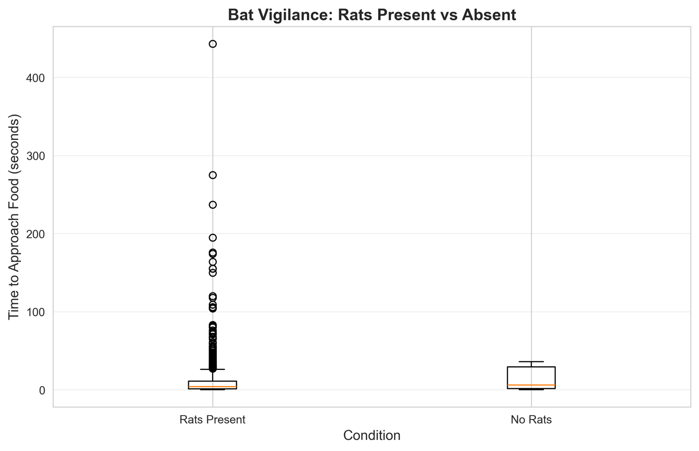

Bats become more vigilant when rats are around. The boxes show the spread of wait times.

## 3.2 Risk Behaviour

The zoologists used a clever coding system for risk. They marked “risk” 1 if the bats attacked the rat for food. If the bats wait it out and avoid the rat, then the code was “risk” 0. The split was almost 50-50.

* Risk-avoidance: 458 events (50.5%)
* Risk-taking: 449 events (49.5%)

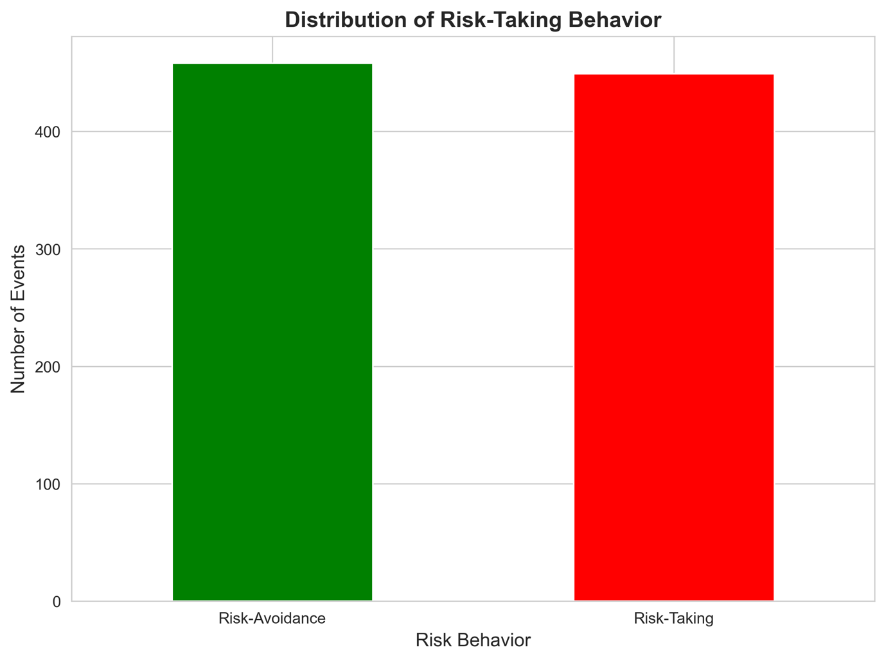

Figure 2: About half of the respondents avoid rats while the other half confronts the rats.

If rats were scary predators, we'd see way more avoidance. However, it turns out that bats will go for the rats. This suggests that they might not mind eating rats, with it being a competition between the two species.

## 3.3 Success Rates

Now this is where it gets really interesting. We looked at which strategy actually works.

* Risk-takers: 21.8% got food
* Risk-avoiders: 84.3% got food

Chi-square test was very significant (χ² = 352.83, p < 0.0001). Avoiding rats works way better - about 4 times better. It seems like bats aren’t bothered by rats, but rats disturb their feeding. It seems that through competition, the rats are dominating the food platform.

## 3.4 Timing Patterns

Bats landed at an average of 282.88 seconds (about 4.7 minutes) after rats appeared. The delay in attacks suggests the bats took note of the rats and may have waited for them to leave. It seems the captain is actively observing the landing situation, not being overly cautious.

## 3.5 Summary

Three things point away from the predator hypothesis.

1. No increase in carefulness with rats present (p = 0.83)

2. Half of the bats directly confront rats instead of always avoiding.

3. The impact seems competitive (reduced success) not predatory (fear/danger).

Rats have a clear marginally detrimental impact on bat feeding success by competing for the same resources (84% vs 22). The finding of the delay shows that bats are aware of rats but respond through when they show, not how carefully they act once there.

In all, the rats are strong competitors that monopolise the food, rather than being predators that threaten bats.

# 

# 4. INVESTIGATION B: SEASONAL ANALYSIS

We observed whether bat behaviour changes by season and found some pretty clear evidence.

## 4.1 Seasonal Distribution

The data had two seasons

* The first recorded winter storm spanned from December to February
* Season 1 had 756 observations (probably March to May)

There was a lot more data available in season 1 that we kept in mind when interpreting results.

## 4.2 Vigilance Across Seasons

The difference was statistically significant (t-test: t = -2.77, p = 0.006)

Season average, median, standard deviation, and count in seconds.

|  |  |  |  |  |
| --- | --- | --- | --- | --- |
| Season | Mean (sec) | Median | Std Dev | Count |
| 0 | 6.04 | 2.00 | 13.96 | 151 |
| 1 | 12.85 | 4.00 | 29.51 | 756 |

Season 1 bats wait more than twice as long before eating. People are more cautious during spring/summer when they think there is more food. Why would they be more careful when food is abundant?

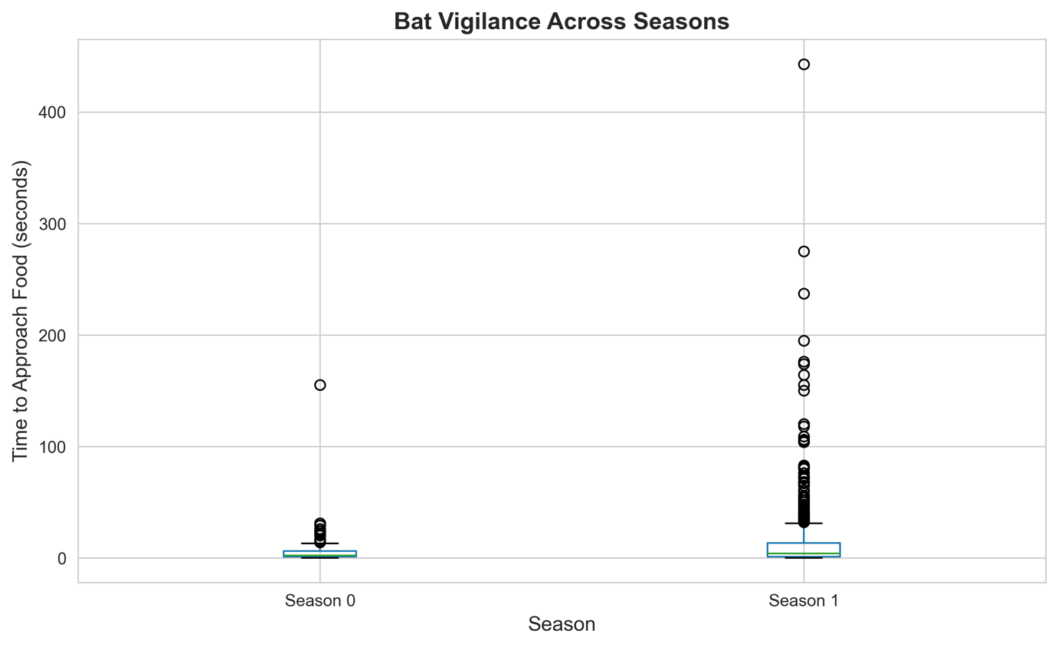

As shown in Figure three, there is a clear seasonal wait difference.

## 4.3 Rat Activity

The number of rats arriving increased significantly in season 1:

|  |  |  |
| --- | --- | --- |
| season | Mean Arrivals | Total |
| 0 | 1.24 | 210 |
| 1 | 0.60 | 734 |

There are 2.5 times more rats in spring/summer. Now that we know there are more bats, the increased vigilance makes more sense: more competition.

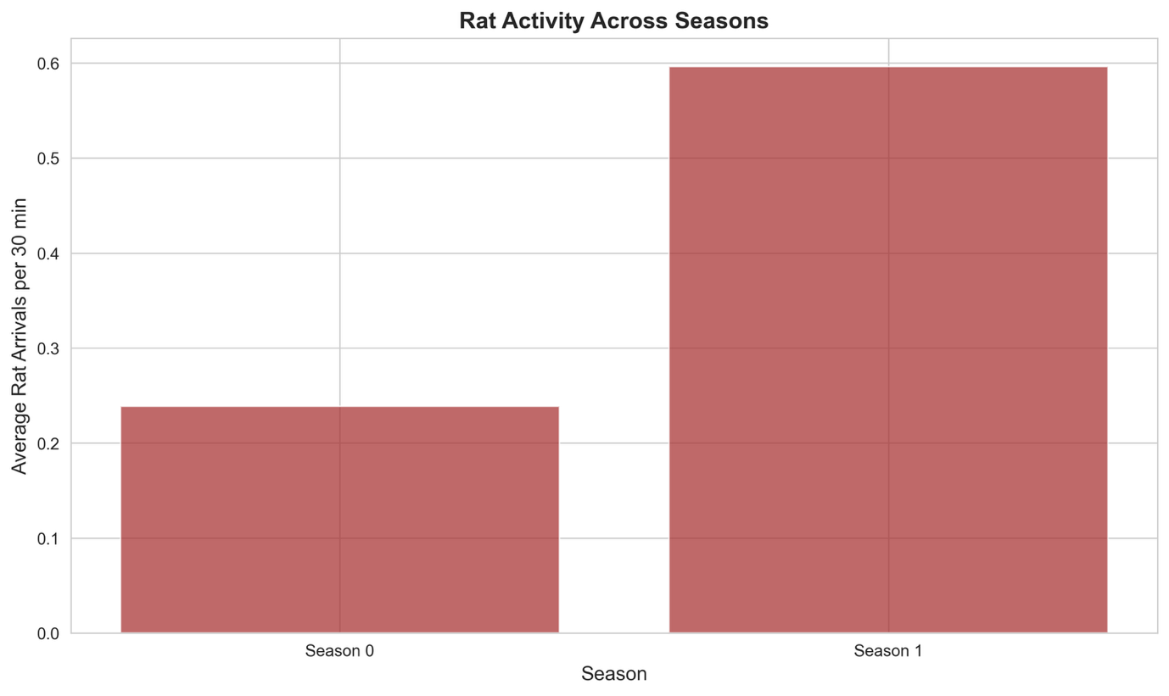

Rat activity in Season 1 more than doubled (see Figure 4).

## 4.4 Changes in Risk Taking

The proportion of risk-taking shifted between seasons.

- In Season 0, a percentage of 56.3 percent took a risk.

- In season one, a total of 48.1 percent of people took risks.

As we can see from Figure 5, there was a slight shift towards more caution in Season 1. Interestingly, bats took MORE risks in winter even though there were fewer rats. Maybe food scarcity forces desperate behavior? When you're hungry, you can't afford to wait around.

## 4.5 Bat Activity Levels

Bat landings per 30-minute period.

|  |  |
| --- | --- |
| Season | Mean Landings |
| 0 | 36.76 |
| 1 | 28.66 |

During winter, there are more landings. This suggests more frantic foraging for food.

## 4.6 Success Rates

Here's the surprise finding

Successful Rate of All Seasons

|  |  |
| --- | --- |
| Season | Success Rate |
| 0 | 36.4% |
| 1 | 56.7% |

Even with greater rats and greater vigilance, the Season 1 bats are actually MORE successful - 56% improvement. How does that work?

## 4.7 Putting It Together

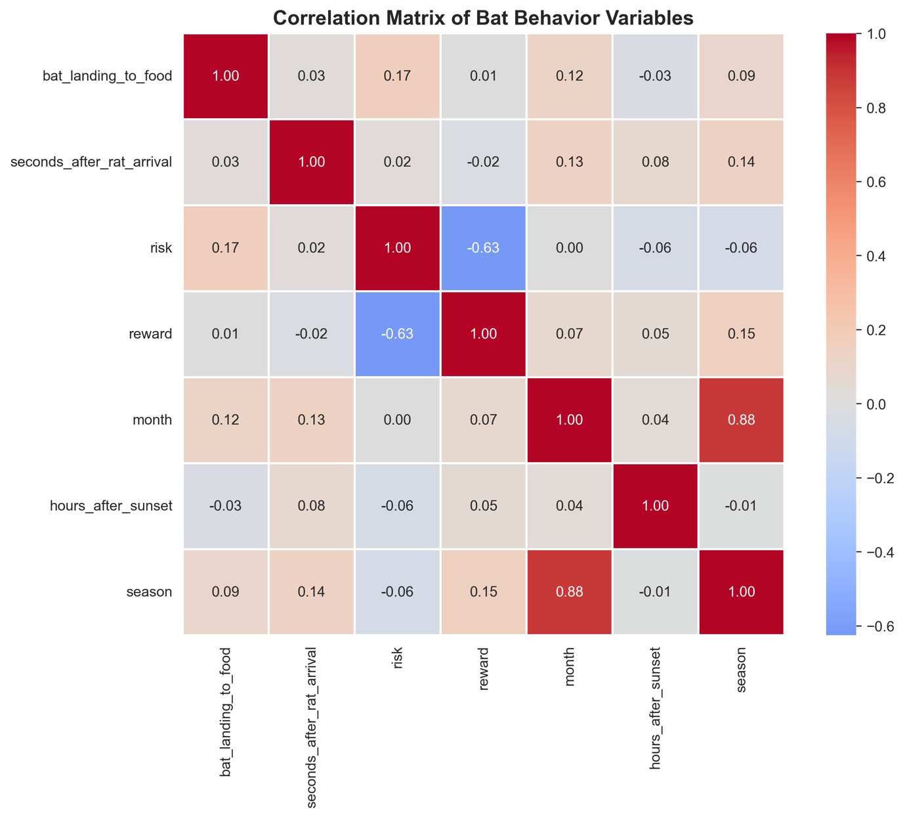

The connections of the measured variables.

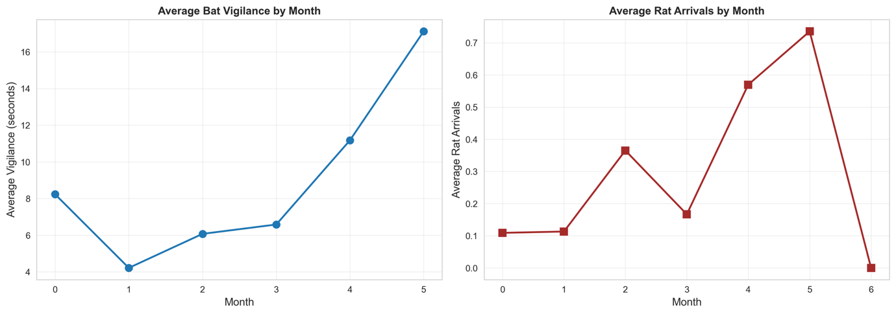

The shifts seen on the months 0 to 5.

Figure 8: Chance of success by season and risk type.

Risk-avoidance is a strong predictor of success (r = -0.63). Trends observed on a monthly basis show that both vigilance and the rat showed an increase as the study progressed.

## 4.8 What This Means

Based on the season, there is an expected trend. In the first season, the rats are 2.5 times more, the vigilance is 2 times higher, the risk-taking is low, but the results are better at 57 per cent versus 36 per cent.

The meaning is winter-limited food, which leads to dangerous, frequent foraging that does not pay well. During spring and summer, the abundance of food allows them to exercise patience and wait for the right moment. Despite facing stiffer competition, a positive outcome is achieved nonetheless.

It's like the differences between desperation (winter) and strategy (summer). If you cannot get what you want, you must be content with what you can get. When food is abundant, it will be a while before they can find one, and you will end up doing better.

The evidence strongly suggests that bat behaviour does adapt to seasons, and bats definitely adjust to environmental changes.

# 

# 5. DISCUSSION AND LIMITATIONS

## 5.1 Main Findings

Investigation A indicates that rats are not seen as predators. The strongest evidence against this idea is that there is no decrease in vigilance when rats appear (p = 0.83). If rats were dangerous, bats would be a lot more careful (that’s basic anti-predator behavior common to many species).

But rats definitely impact foraging. The success rates (84% and 22%) shows that rats monopolise the food. They're dominant competitors, not predators. Bats are expected to select the second-best prey in case they cannot catch the best one first, with a time delay depending on their speed.

The division of risk-taking may reflect individual differences, with some bats being bolder and others more timid. Or perhaps it all depends on how hungry they are or how aggressive the rats seem at the moment.

Investigation B revealed clear seasonal adaptation. In Season 1, vigilance doubled (p = 0.006) along with 2.5x more rats, indicating bats respond to increased competition. Even though the caution ratio is quite high (57% versus 36%), there is also higher success. This suggests that waiting is profitable, as there is a great deal of food around. You can afford patience in spring when resources are good.

The opposite winter pattern shows greater risk-taking but worse outcomes, probably driven by desperation over food scarcity. When resources are scarce, you can run out of time - taking gambles doesn’t pay off as well. It’s adaptive in the sense that failing to do anything would produce worse results; however, it also is not a successful strategy.

## 5.2 Limitations We Should Mention

The sample imbalance is worth noting: Season 0 has only 151 observations, while Season 1 has 756 observations. The sample size might be an issue for our power but our significant results suggest otherwise.

The “risk” was coded based on what the researchers saw in the videos. We could not see how reliably they would score this, nor if different people would classify the same behaviour the same.

Segregation into only two categories of seasons limits fine-scale temporal analysis. We can’t say for sure when behaviours change or if transition periods appear different.

We can't claim causation from observational data. Although we see the patterns clearly, we would need experiments (such as rats' removal) to seriously test this cause-and-effect relationship.

The absence of certain variables may be important. This includes factors such as the weather, features of the individual bat, the precise quality of the food, and the effects of the time of night. Any of these explanations would clarify some of the variation we attribute to season or rat presence.

Generalizability is questionable. This is one colony with artificial food provisioning. Wild populations foraging naturally might exhibit different patterns.

The comparison "vigilance without rats" basically failed because rats were almost always present (only one observation without rats). We couldn't really test baseline behaviour.

## 5.3 Practical Implications

It is important for wildlife management to understand these competitive dynamics in the city and cropland where bats and rats overlap. During our study, we found the winter period to be the stressful period for bats. Thus, giving food during this time may help bats.

According to the study, being able to change your behaviour is important.

Bats that could switch up their game plan each season probably do better than bats that can’t.

# 6. CONCLUSION

Over a period of seven months, we conducted 907 landings of bats and 2,123 observation periods to answer two questions regarding bats and rats.

For predator perception, the answer is pretty clearly no. Bats were equally vigilant in the presence and absence of rats (p = 0.83). Half the bats confronted the rats directly; the effect is competitive (with reduced feeding success), not predatory (fear/danger). Bats are often impacted negatively by rats whenever they feed on the ground. One study shows that bats that don’t go near the rats and choose to avoid them manage to have better chances of succeeding at feeding (84%) compared to those that take the risk and get close to the rats (22%). However, this doesn’t happen because the rats hurt the bats, but rather owing to a strategy of resource monopolisation that the rats and bats engage in.

The timing pattern (283-second delay) suggests that bats do attend to rats, but not in the manner we would expect if rats were predators. It's more like keeping an eye on a competitor than running away from a predator.

For seasonal changes, the answer is definitely yes. In season 1, vigilance doubled (12.85 vs 6.04 s, p = 0.006), the rats’ experience of competition tripled (more rats), and there was a tendency to avoid competition (more risk-averse). Interestingly, success improved a lot (57% v 36%), indicating that patients waiting works when food is plentiful.

In winter, animals appear to forage in risky, low-success approaches. Spring appears to enable careful foraging with high success. It shows that they can change their behaviour based on their environment.

Our quantitative analyses support the contention that the bat-rat interactions are competitive and not predatory, bats employ season-specific bait-switching strategies, and behavioural flexibility is key to handling variable conditions.

There are many interesting additional studies that could take place. For example, one could track individual bats to see personality differences or do experiments removing rats to show this is causative. Or one could study the transition periods between seasons to see when behaviours start to switch. We could see if these patterns hold in other colonies if we compare multiple colonies.

# 

# 7. REFERENCES

* Chen, X., Harten, L., Rachum, A., Attia, L., & Yovel, Y. (2025). Complex competition interactions between Egyptian fruit bats and black rats in the real world. Mendeley Data, V1. <https://doi.org/10.17632/gt7j39b2cf.1>
* McKinney, W. (2017). Python for Data Analysis (2nd ed.). O'Reilly Media.
* Pandas Development Team. (2024). pandas documentation. <https://pandas.pydata.org/>
* Virtanen, P., et al. (2020). SciPy 1.0: fundamental algorithms for scientific computing in Python. Nature Methods, 17, 261-272.
* Hunter, J. D. (2007). Matplotlib: A 2D graphics environment. Computing in Science & Engineering, 9(3), 90-95.

# 8. INDIVIDUAL CONTRIBUTIONS

* **Harsh Rastogi(S386401)**: Data cleaning and Investigation A analysis. Created plots 1, 2, and 6. Wrote the Introduction and methods sections. Set up a GitHub repo and coordinated meetings.
* **Princyben Chetankumar Patel(S388343)**: Implemented season mapping for Dataset 2. Ran Investigation B analysis and stats. Made plots 3, 4, and 5. Wrote the entire Section 4 results. Created all tables.
* **Hena Akter(S383478)**: Literature review and background research. Wrote Investigation A results (Section 3), Discussion (Section 5), and Conclusion (Section 6). Made plots 7 and 8. Formatted the Word document.
* **Renish Rajeshkumar Vekariya(S374427)**: Validated calculations and tested code. Did quality checks. Prepared documentation and repository files. Handled Turnitin submission and AI declaration form. Organised the final ZIP file.

All members participated in analysis discussions, result interpretation, and document review. Meetings were documented on Microsoft Teams throughout the project.